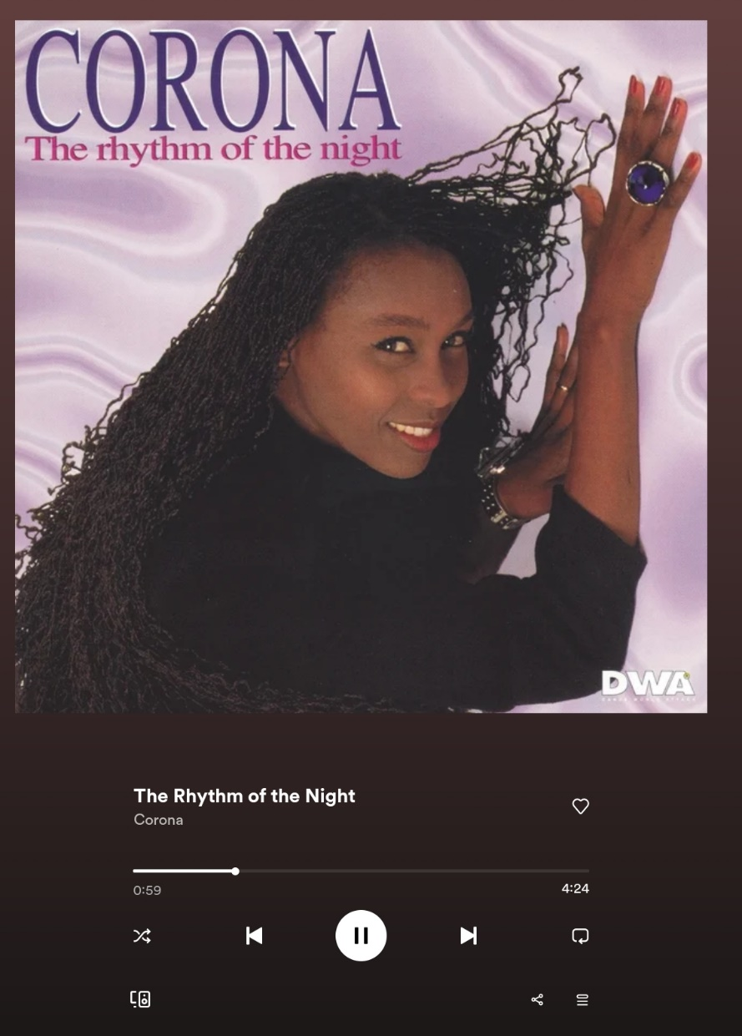

THIS IS THE RHYTHM OF THE NIGHT  
THE NIGHT, OH, YEAH  
THE RHYTHM OF THE NIGHT

THIS IS THE RHYTHM OF MY LIFE  
MY LIFE, OH, YEAH  
THE RHYTHM OF MY LIFE

YOU COULD PUT SOME JOY UPON MY FACE  
OH, SUNSHINE IN AN EMPTY PLACE  
TAKE ME TO TURN TO  
AND, BABE, I'LL MAKE YOU STAY

OH, I CAN EASE YOU OF YOUR PAIN  
FEEL YOU GIVE ME LOVE AGAIN  
ROUND AND ROUND WE GO  
EACH TIME I HEAR YOU SAY

THIS IS THE RHYTHM OF THE NIGHT  
THE NIGHT, OH, YEAH  
THE RHYTHM OF THE NIGHT

THIS IS THE RHYTHM OF MY LIFE  
MY LIFE, OH, YEAH  
THE RHYTHM OF MY LIFE

WON'T YOU TEACH ME HOW TO LOVE AND LEARN?  
THERE'LL BE NOTHING LEFT FOR ME TO YEARN  
THINK OF ME BURN  
AND LET ME HOLD YOUR HAND

I DON'T WANNA FACE THE WORLD IN TEARS  
PLEASE, THINK AGAIN, I'M ON MY KNEES  
SING THAT SONG TO ME  
NO REASON TO REPENT